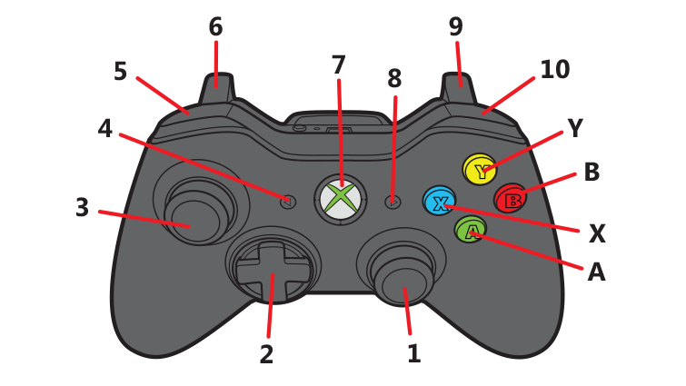

|  |  |
| --- | --- |
| 1. Nothing 2. D-pad:   Up: Zero turret  Left: Turn 45 degrees left  Right: Turn 45 degrees right  Down: Nothing   1. Nothing 2. Set shoot speed to pit shot 3. Move turret counterclockwise | 1. Hold to aim using camera vision 2. Nothing 3. Nothing 4. Press to shoot balls 5. Move turret clockwise   Y: Set shoot speed to far shot  B: Set shoot speed to medium shot  A: Set shoot speed to short shot  X: Set shoot speed using vision |

